Create a new NAT Network

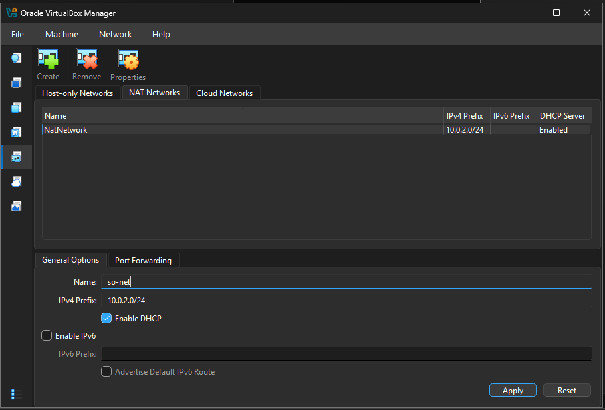

Then create a new VM.
Provide a name for the virtual machine (Security Onion 2.4 for example) and then select the ISO image. It should automatically set type to Linux and version to Oracle Linux 9.x. Click the checkbox for Skip Unattended Installation and then click the Next button.

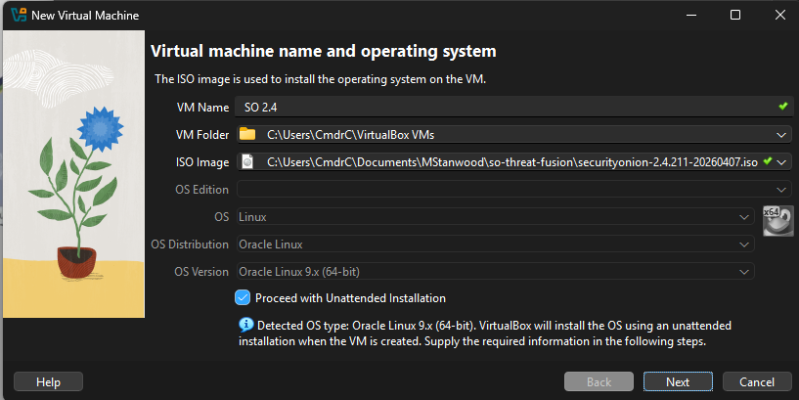
Select “Unattended Installation”
Set Username and password and a Hostname

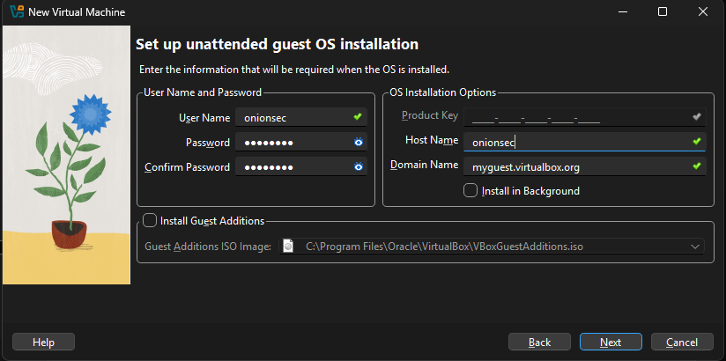

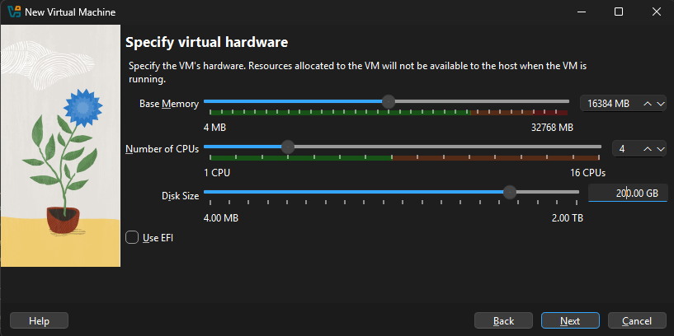
Set memory 16384 MB
Set 4 CPU
Set 200 GB hard drive
FINISH
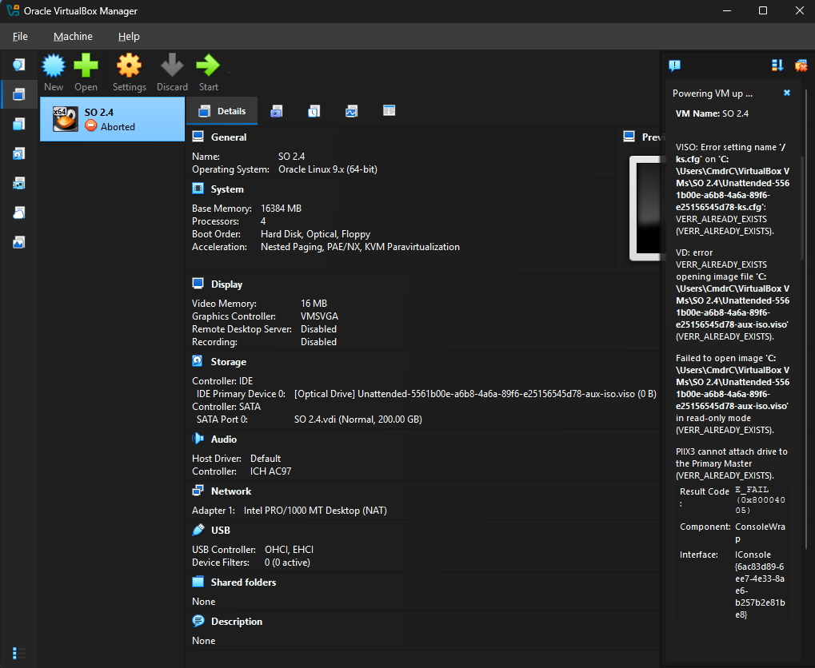
Get Error. Now We need to configure storage.

Select the VM “SO 2.4”, then settings
In settings window, select “Storage”, then controller IDE, then select the security onion iso image.
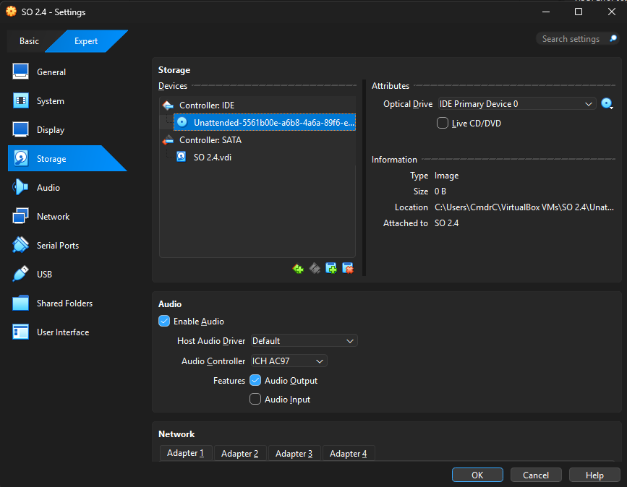


Configure Network
NOTE: Make sure to take notes of the MAC addresses assigned. We are going to select the correct NIC later to be the SO-Management (and they have to match)

Adapter 1
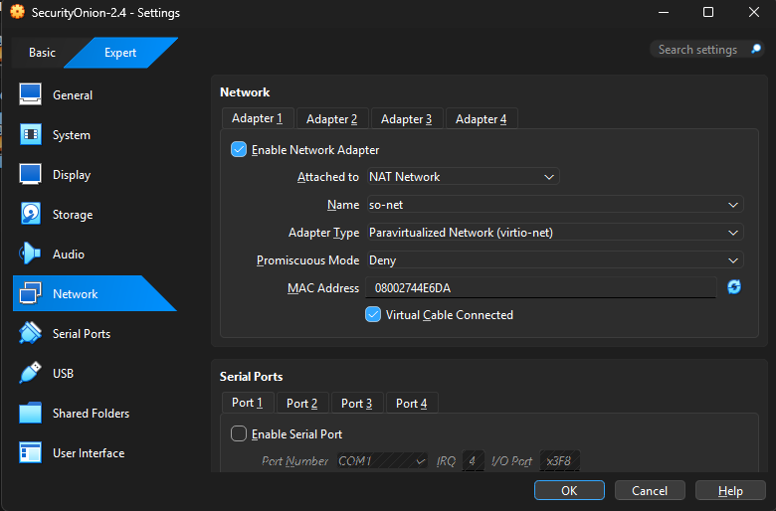

Adapter 2
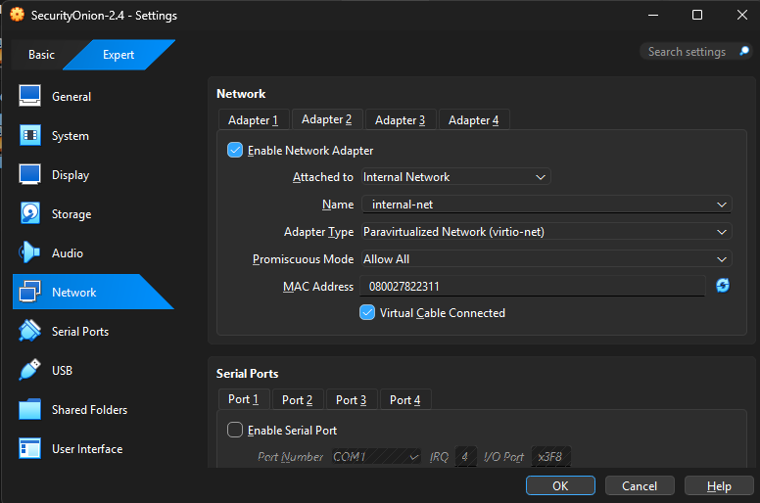

---

Restart VM
- If asked to delete unnesesary files, say yes

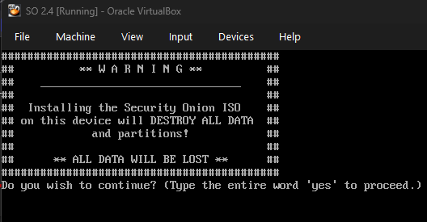
Type “yes” to proceed

Then Create a new User and Password for Security Onion ISO example:
User: onionsec
Password: 0n10nsec

Next it will take some time to install the operative system.
Then will ask to Restart VM. After Restart will request the user and password created for Security Onion ISO (previous step)

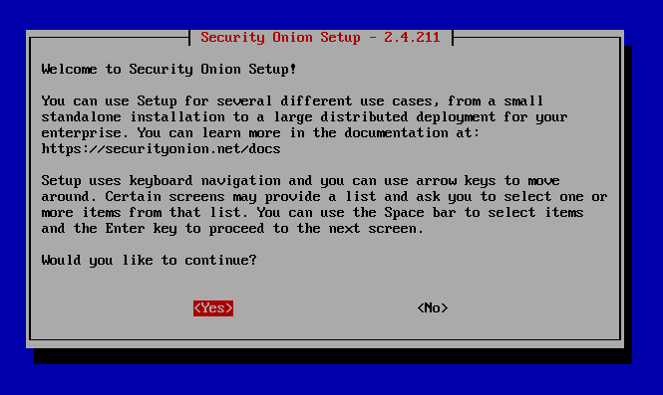

Select “Continue” with installation
Then select “Install”
The select “STANDALONE”
Then type “AGREE”
Then write the hostname “<myname>_secureonion”
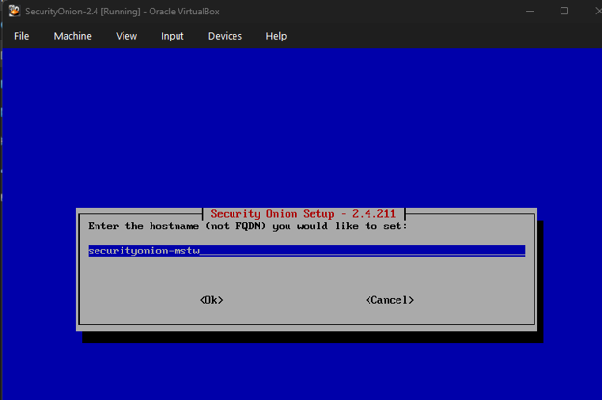
Then select DHCP

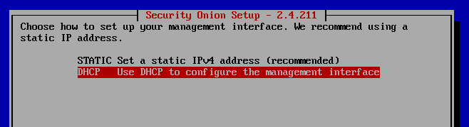

Then select the NIC that matches the Adapter 1 to be the Security Onion Management

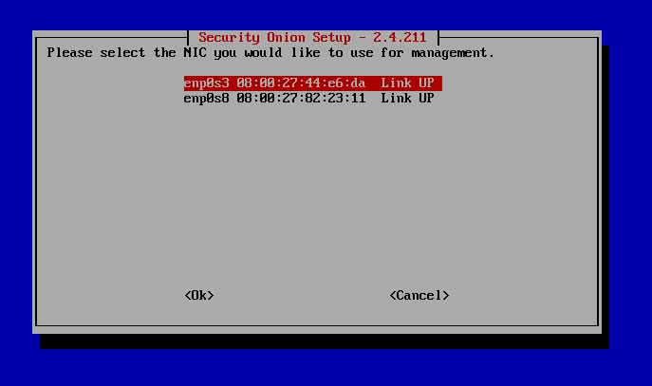

Select Direct
Keep defaults on docker


Select the Adapter 2 (promiscuous mode one) using the arrows and the SPACE key

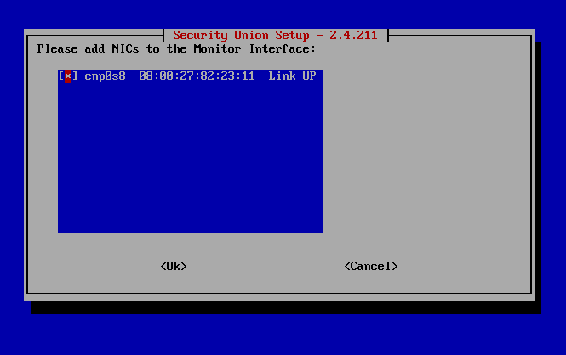

Write an email to login
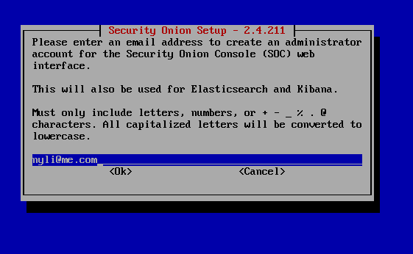

Select “IP” to access the security onion web interface
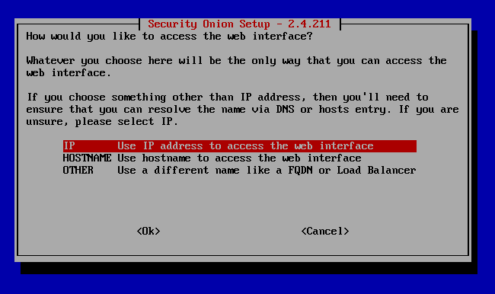



ALOWED network must match the one configure in NAT Network 10.0.2.0/24

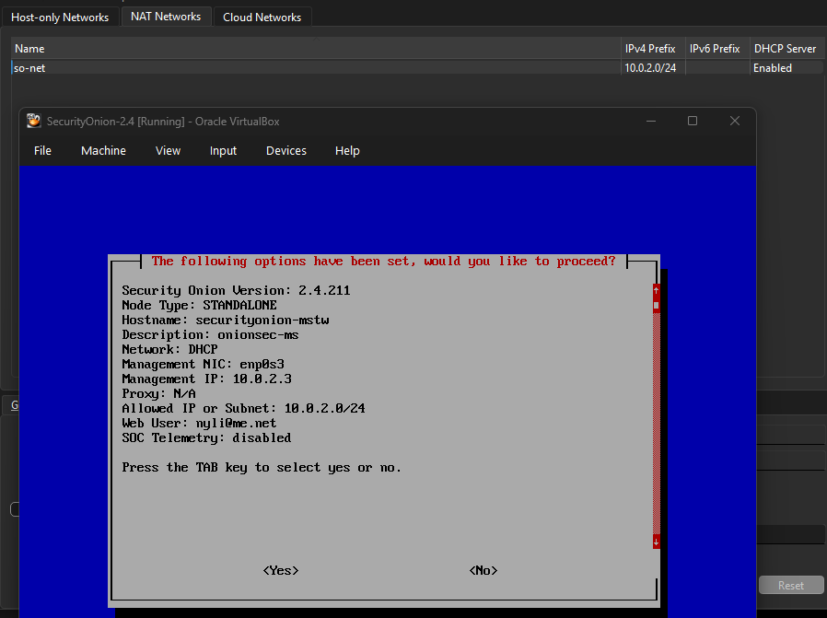

It will take some time 20 to 30 minutes to finish installing all security onion tools.
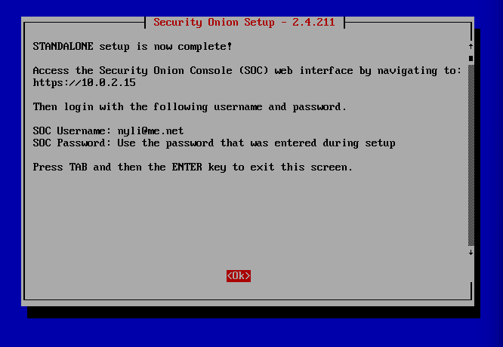

sudo so-status

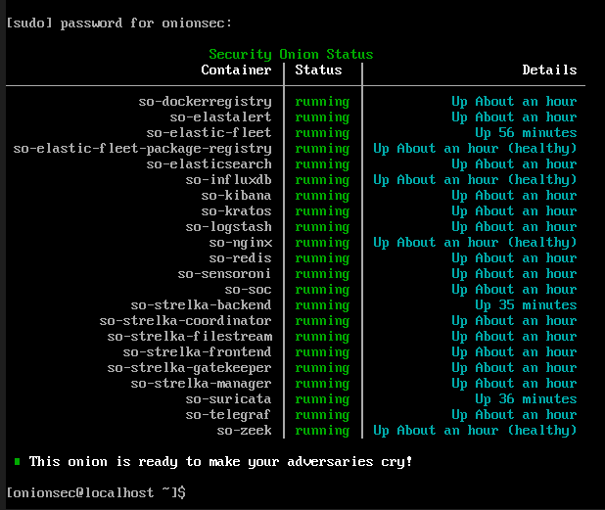
Ifconfig to identify the IP
---
Download the VM ready .vbox file, double click to install Kali linux
Configure the Adapter 1 and Adapter 2 before starting the machine
In kali
Ifconfig to identify the IP
Ping security onion
then in the browser open https://<ip-of-security-onion>
login with the user and password from previous step

